SHERWOOD COMMUNITY ASSOCIATION CIO
Registered Charity 1158333

ANNUAL REPORT OF THE TRUSTEES

2025-2026

Sherwood Community Association CIO is the Registered Charity which runs

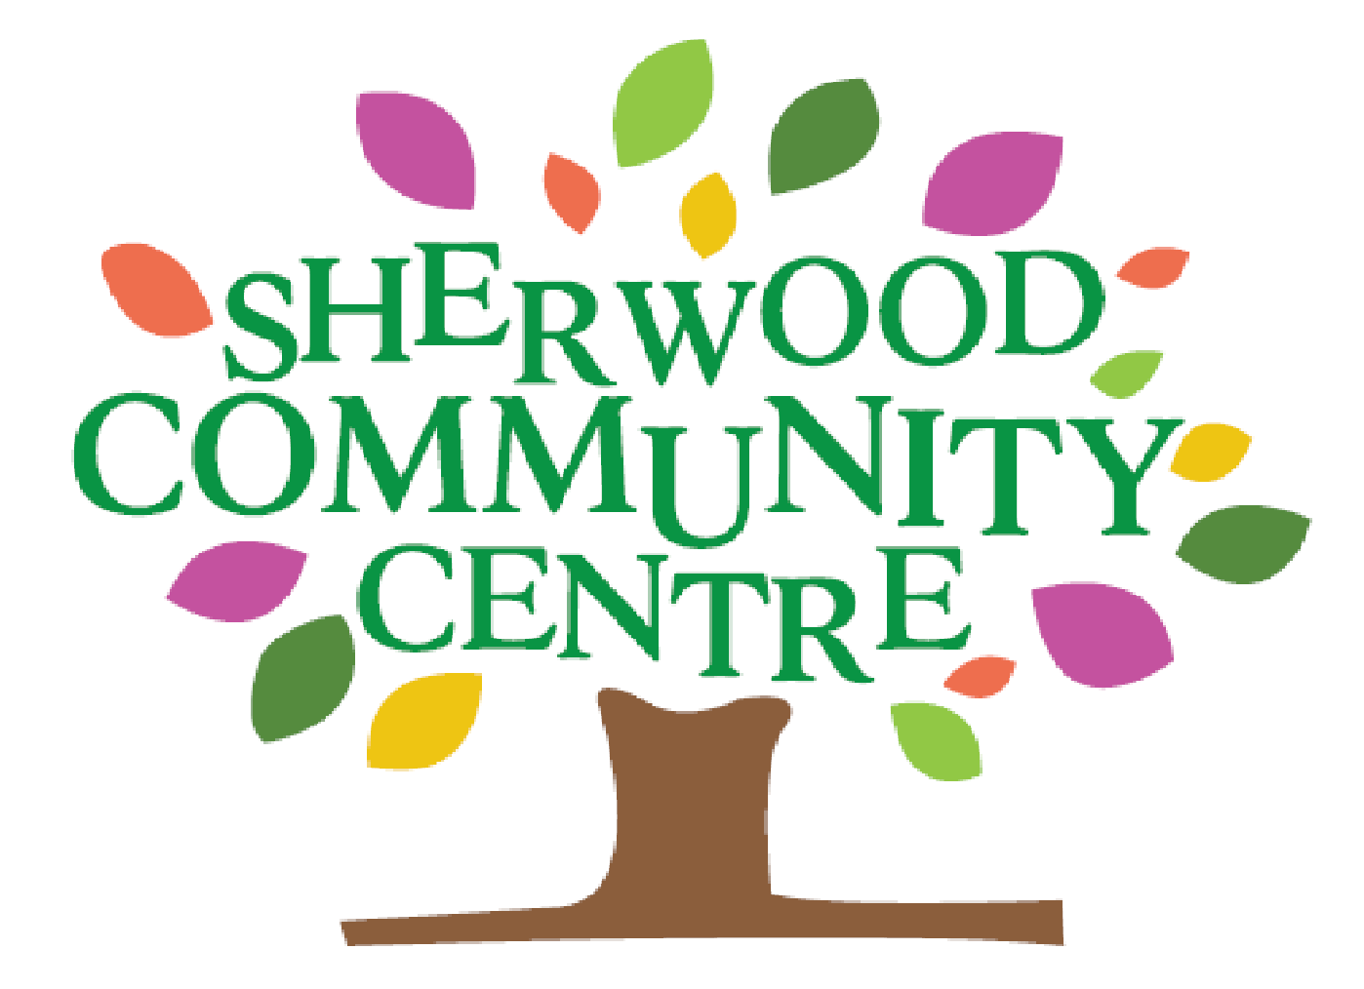

Contents

Trustees’ Report 3
Trustees and Staff 4
Chair’s Report 5
Membership Secretary’s Report 6

Financial Statement 7

Sherwood Community Centre and the
Environment 7
Book-sharing 8
Affiliated Groups’ Reports 8

Appendix:
2025-2026 Accounts 15

TRUSTEES’ REPORT 2025-26

ABOUT SHERWOOD COMMUNITY ASSOCIATION CIO

The Sherwood Community Association CIO is a Charitable Incorporated Organisation, (Reg. No.1158333), a voluntary organisation which was first registered with the Charity Commission on 22nd August 2014. From 1st April 2015, this charity took over the running of the Sherwood Community Centre, and all the monies, assets, contracts etc. of the former Sherwood Community Association which was then closed.

Full SCA CIO Membership is open to anyone living, working or volunteering in the area of benefit (which is Sherwood and the surrounding area) or attending a group at the Centre.

The Association is managed by The Trustees' Committee who meet monthly, assisted by two Administrative Assistants. The Trustees are elected annually by the members at an AGM and operate as per the adopted Constitution of 2014. It is a condition of Affiliation that representatives support the Association by providing assistance at events or helping in areas of their expertise.

The Trustee group meets on a monthly basis and additionally holds relevant meetings when needed throughout the year.

The building and grounds are owned by Nottingham City Council, who continue to be responsible for all repairs to the structure and services of the building up until a lease hand-over date is agreed.

The current Trustees’ Committee has endeavoured to be in contact with and work with other organisations and charities to enhance provision for all who live in the area of benefit. We regularly use Social Media to promote our activities, user groups and events on Facebook and Instagram and also have a page for the cafe Sherwood Community Cafe.

Through the democratic process, a wide range of views and opinions have been expressed, debated and decisions made accordingly. Each calendar year we hold a Community Forum as per the Constitution, where we invite a diverse group of people from the Area of Benefit to share their experiences, challenges and successes, and to hear updates about all that is on offer at the Centre. More than 80 individuals attended the most recent Sherwood Community
Forum. We had time for a presentation about the history of the Community Centre, refreshments and conversations, alongside networking, tours of the

building and discussion around the importance of Community Centres across the city and the challenges we face.

Present provision and services continue to be utilised and we have had success in responding to identified needs and being awarded grant funding.

TRUSTEES AT 31 MARCH 2026

Chair | Tracey Louise Holland
Treasurer | Eva Codrington
Secretary | Hannah Fries (also known as Hannah  Malhotra)
Membership Secretary  Trustee | Valerie Hunter  Jill Gregory (also known as Jill Mee)

MEMBERS OF STAFF 2025/26

Administrative Assistants  Compliance administration | Sue Packman  Meily Cheung  Adam Cliff (Compliance/Website etc)
Caretakers | Adam Cliff  Sam Holland  David Harper (till 23.02.26)  Michael Bellamy (from 29.03.26)
Café Employee  Community Support and  Development Worker | Jayne Marriott (term time only)  Jules O’Donnell (from 01.03.26)

STATUTORY AUTHORITIES

Resident Development Officer (Nottingham City Council)

CHAIR’S REPORT

I joined the General Committee of Sherwood Community Association in 2010 and became Vice-Chair of The Association in 2024 and Chair in 2025 following the resignation of Jill Gregory who has continued to be a Trustee in this financial year and support the handover of information.

2025-26 has been a challenging year where Nottingham City Council have ceased to paying for grounds maintenance, water rates, waste disposal, health and safety training. The plan from 2024 was to make Community Centres financially self-sustaining including taking on a full repair lease.
We are therefore relying more than ever before on rental income from
Meeting Rooms, Hall and Office hire. Prior to this plan, Community
Associations which were set up in the 1950’s were heavily supported by the
Council and received grant funding from the Council to carry out work in 30 Community Centres across the City. The plan will bring many additional challenges financially and time-wise and adds additional responsibility to volunteer Trustees and our small staff team.

We have been successful in being awarded some grant funding. However, as the Council owns the building, we are restricted with some applications which require long leases and leases without a break clause. We have continued to negotiate with Nottingham City Council around lease terms. Ourselves along with 20 or more community Centres in the City protested against Commercial leases being imposed on our Centres and were also the focus of a Campaign from The Nottingham Post to support us. This would have been financially unsustainable for our Centre.

We have gratefully received donations supporting our work as a charity offers of voluntary help with a range of tasks needed to sustain our busy Centre.

I have had a very busy year liaising with other Community Associations, the Council and spending time considering building repairs and health and safety tasks. Myself and other Trustees and Staff are working together to support the future of the Community Centre and its many charities and groups, to provide help, events, social connection, leisure, well-being, exercise and education to the local community. We are grateful for all the organisations and groups who work within our walls and alongside us.

In this financial year we have celebrated 75 years of Sherwood Community Centre and hope to have many years ahead of us. In March 2026 we appointed a new role of a part-time Community Support and Development worker funded by the National Lottery for two years. This role will enable time for increased partnership working and additional events and activities.

Louise Holland - Chair of Sherwood Community Association CIO

MEMBERSHIP SECRETARY’S REPORT

The 5 Affiliated groups from last renewal period of April 2025 have continued to use the Centre: Elevation Dance, Jill Gregory School of Dancing, Nottinghamshire Bobbin Lace Society, Sherwood Playgroup CIO, The Yoga Village.

From within these groups, there was a total of 37 listed members, and with 78 Individual memberships and 1 Life member, the total membership is listed as 116 at 31.03.26. 90% of the registered membership are City residents.

This is an increase of 8 individual memberships since the previous reporting period, due mostly to the website offering free membership, with on-line applications, though manual applications on the standard form are welcomed. Once applications are processed, new members are contacted by email to confirm membership, and asked to collect their membership card from the Centre. Members are unable to claim any membership benefit without production of their current card.

The majority of Representatives from Affiliated Groups have continued as full and active Trustees, thereby devoting a huge amount of personal time to supporting all the other groups who meet at the Centre.

There is always a need for new Individual members who are able to commit to supporting activities, to become involved, and share the load.

All current individual memberships registered at the end of the Membership year (March 2026) have had their membership extended to the new period, without further charge. Affiliated Groups were asked to continue their annual fee to maintain their status and benefits, with no increase for 2026 - 27. New applications for free Individual membership will still be welcomed, until such time as a review recommends new criteria and fee levels.

Group Full Members
Sherwood Playgroup CIO (Affiliated Charity) | 4
Elevation Dance (Affiliated) | 7
Nottinghamshire Bobbin Lace Society (Affiliated) | 23
Jill Gregory School of Dancing (Affiliated) | 1
The Yoga Village (Affiliated) | 2
Individual Members | 78
Life Member | 1
TOTAL | 116

Valerie Hunter - Membership Secretary

FINANCIAL STATEMENT

See Financial Statement in Appendix

SHERWOOD COMMUNITY CENTRE &

THE ENVIRONMENT

Please help us to do our bit for the planet! We would like to continue our work on reducing our energy consumption of:
Water | Light | Heat
Check that non-automatic taps are off after use. | Please turn off lights if you leave a room.  Don’t put them on if it is a bright day and you can manage without. | Turn room thermostats down a degree or two, or  to zero when you leave a room, as hot water in the pipes helps to  maintain warmth in the rooms.

If you live too far away to walk, then perhaps you may be able to cycle to the Centre and take advantage of our bike bins to lock away your bike whilst using the Centre. There are also buses running past the Centre regularly, with bus stops within 2 minutes’ walk. If, however, you do have to use your car to visit the Centre, please respect the car park markings and blue badge parking spaces, and park considerately. If the car park is busy and you have difficulty parking, there is space on Woodthorpe Drive, opposite the Community Centre, which is well-lit and wide. Alternatively, car parks are available a short walk away in Sherwood.

The little things we do can make a big difference, so please continue with your efforts helping us to reduce our carbon footprint.

BOOKSHARING

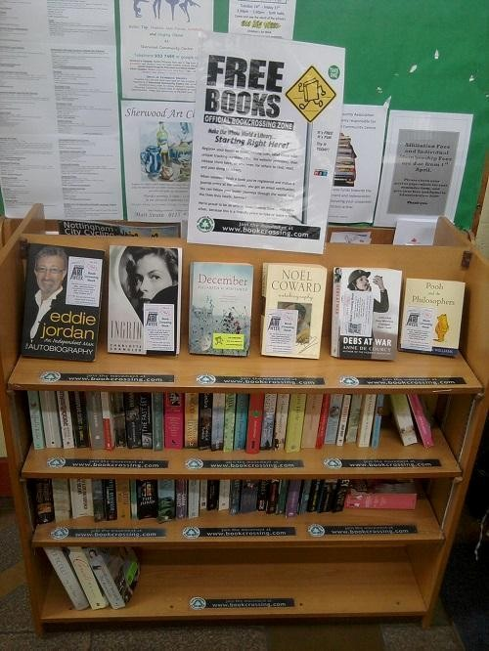

Books displayed in the Cafe can be borrowed and returned or passed on to friends. If you don’t return the book, we ask that you replace it with another book that you have read to enable the shelves to stay stocked.

AFFILIATED GROUPS’ REPORTS

Sherwood Playgroup CIO

Sherwood Playgroup has been running for 65 Years at Sherwood Community Centre. It is open on a Tuesday – Friday Term Time pattern where children can attend between the hours of 9.15am and 4pm for up to 38 weeks of the year. Many families now choose to do three full days to complete their allocated funded entitlement. We have a settled, well qualified and experienced staff team who attend regular training and professional development sessions both linked with the Local Authority and beyond. We continue to offer placements to students from NTU Nottingham Trent University whom we have a strong links with. We work with the Education and Psychology departments as well as students who wish to have experience of working with a range of children including those with Special Educational Needs. We have also worked with The Best Practice Network to support staff training through the Initial Teacher Training Scheme. We have two long term volunteers who have childcare training and Childcare qualifications are a fantastic support and volunteer on a weekly basis.

We work closely with Nottingham City Council's Early Years team and follow guidelines set by the Department of Education alongside OFSTED Registration and following the Early Years Foundation Stage Statutory Framework. We have children who benefit from funded places due to the Two-Year-Old Early Learning Programme, the Thirty-Hour scheme for working Parents alongside the Universal Entitlements for children following the term of their third birthday.
We have children who receive funding through the Higher-level needs funding administered through the Local Authority. Children who have Special Educational Needs or a disability often work with a range of local Authority staff including the SEND team, Speech and language therapists Teachers of the Deaf, Learning Support staff and the Autism Team. Increasingly more children have been staying with us two years or more until they move to a full-time school place school and some children stay with us longer as they will be home educated. Many Parents/Carers seek us out due to hearing positive feedback from others who support our ethos. We continue to have a waiting list and receive many telephone and email enquiries, as well enquiries from our Facebook/Instagram Page and website: www.sherwoodplaygroup.co.uk
At times when we have the staffing capacity, we run small Stay and Play Sessions for those living locally to become familiar with the Community Centre and Playgroup. We fully support Community Centre activities by promoting and attending when we can as well as supporting the Sherwood Community Café on site. Our new families in particular find it really helpful to be able to have a warm drink and a snack whilst their child is settling and often bring others to use the Café.
We are grateful to The Masonic Charitable Foundation who have supported us through giving a grant combined with Pupil Premium Money and Co-op Causes money to fund outdoor sessions. We were able to pay “Into the Wildwood” for weekly Forest School sessions up until July 2025 which impacted positively on children’s resilience, awareness of seasons and nature and develops their physical skills.
We have some children in receipt of pupil premium money which is used in many variable ways depending on their needs and interests. We are grateful to the Wildlife Trust and the Keeping it Wild Team for their continued support and allowing us to use Woodthorpe Meadow which provides so much learning potential through the seasons and in all weathers.
We are grateful to our local Co-op who have who have supported some of our events with funding, resources and refreshments including an event for parents and families. We are also very fortunate to be in a thriving Community Centre where groups such as Open Wings and Elevation Dance have supported some creative, dance and musical activities which brings new experiences to our group.
We are thankful to our Parents/Carers and wider community who acknowledge the difference that our small setting makes to children’s lives and development in their Early Years in the broadest sense. We are always grateful for donated items that we use on a regular basis, such as wet wipes, cleaning materials, playdough ingredients and fruit and veg. Our finances are satisfactory at the moment although 97% reliant on Government funding rates. However, for now we are covering our costs and aim to offer any additional non-funded hours at an affordable level to families. We welcome grants, donations and legacies to support the continuing work of Sherwood Playgroup CIO within our city and local area.
Louise Holland / Jayne Lowe – Co-Managers Sherwood Playgroup CIO sherwoodplaygroup.co.uk Representatives to SCA CIO

Jill Gregory School of Dancing

The Ladies Advanced Ballet and Tap Classes continue to run every
Tuesday during term time, as well as an additional Modern Jazz group. In March 2026, these groups performed in "A Year in Motion", the show produced by our partner school, Elevation Dance, which was formerly the Jill Gregory School of Dancing. The Ballet group performed to Primavera and the Tap and Modern Jazz groups were combined for Hazy Shade of Winter. Some members of the group have been attending for as long as 10 years, although some for only a couple of years. They are a really enthusiastic team, who get on really well together. As well as enjoying the classes, some say it is really helpful for their mental health as well as fitness and relaxation.

The Wednesday Tap class was paused during the summer term 2025 in the hope that a problem with my foot would be resolved for recommencing in September or after the Tapathon in November. Members of the class therefore attended Elevation Dance classes in preparation for the Tapathon, but as the foot problem was not resolved, the transfer became permanent. As some of the members of the class had joined as beginners in 2013, I was sorry to have had to pass the class on.

Although my classes are only running once a week, I am looking forward to celebrating 50 years of running dance classes at Sherwood Community Centre, in September 2026.

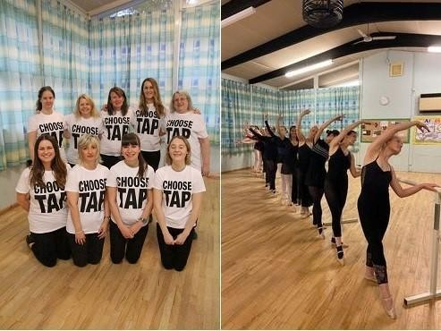

Jill Gregory - Representative to SCA CIO

Elevation Dance

The end of our 2024-2025 academic year was a busy one for us as we focused on community events and exams. We had lots of fun at our annual dance school picnic, and performed as part of Sherwood Art Week and Sherwood Community Centre’s 75th Anniversary event. Our youngest and newest Elevation Dance member came along to watch these performances at just a few weeks old, as I had a baby boy in June!

We finished off the year with some British Theatre of Dance Association (BTDA) exams in July. Our students worked very hard, and we had 47 exam entries with 100% pass rate.

In August, we ran a three-day movies themed summer school. This was our third summer school, with fantastic uptake once again. We had great fun running dance sessions, arts and craft activities and games, and had a visit from a guest teacher who lead an acting workshop. We rounded off our summer school with a small showcase of what had been learnt in the week, inviting parents and family members in to watch.

We welcomed some new members in our classes in September for our new academic year, and began preparations for exams and learning this year’s charity Tapathon dance. The annual Tapathon for Children In Need took place in November, and along with the Jill Gregory School of Dancing, we had 60 dancers taking part. Entry fees went towards a national donation of £37,000 for Children in Need, and we raised an additional £194.52 from selling homemade cakes and accessories on the day. We had an exam session in November, with a total of 25 examinations and 100% pass rate achieving Merit or above. 77% of entries in this session achieved a Distinction or Honours grading. We were very proud of everyone’s hard work!

With exams and the Tapathon completed, we could turn our attention fully to preparations for our March 2026 show, Going A Year in Motion! We performed on the 21st and 22nd March at Djanogly School Theatre. Our dancers loved performing, and our audience loved taking a journey through the year in dance with us. At Elevation Dance, we are so proud to have created a friendly community where everyone has opportunities and can be included, and I feel our show really highlighted our community and vision. We’re still awaiting our final show proceeds amount due to a few last-minute show film orders, but proceeds will be split between local charities Rainbows Hospice for Young Children and Adults, Mind and Women’s Aid, as well as going towards improvements on the Small Studio and Annex waiting area.

Yasmin Sidery - Representative to SCA CIO

Nottinghamshire Bobbin Lace Society (NBLS)

NBLS Report to SCA CIO for April 2025 – March 2026.
Our membership figures have risen this year, and at the end of this reporting period, there are 150 adult members; 8 of these are new memberships.

Regular classes and self-help groups around the county, the seasonal Lace Days and Pop-ins continued as normal, though attendances varied. The AGM was held in November 2025 and the Committee for 2025– 26 was established, with some new Committee members, including a new Chairman. In a change to our customary practice in previous years, we had voted at the 2022 AGM to give support to 4 chosen charities over a period of 2 years: Hayward House, Motor Neurone Disease Research, Parkinsons UK Research and baby Anayah Israel (a personal link to the Society, in need of specialist medical treatment abroad.) All have close links to NBLS members. Funds were raised from equipment sales, cake sales, raffles and direct donations, and interim payments of £200.00 had been sent to each last year. This year a further £2,560.00 has been distributed to the 4 nominated charities. The new charity nominated at the AGM in November is Guide Dogs for the Blind.

After considering the future of Lace Days and increasing costs of venues, the Spring Lace Course was removed from the diary, and a series of workshops at a Pop-in offered instead. The annual Residential Weekend Lace Course returned to Eastwood Hall in June, where four nationally known tutors offered tuition in a variety of types of lace. Regular Spring and Summer Lace Days went ahead at the usual venues around the county, including the AGM in November and the Anniversary Lace Day in January. There is usually a Speaker at these events,

which always adds to the attraction of the day, as well as the opportunity to buy equipment from the visiting suppliers. However, Lace suppliers are dwindling as the owners retire, or are no longer able to travel to various parts of the country to sell face-to-face. and sales transfer to on-line business. NBLS is lucky to have a local supplier who is also on the Committee as Secretary.

Several Self-help groups and classes are run elsewhere in the county, and Pop-ins and a weekly Self-help group for NBLS members run at Sherwood Community Centre. From September, a new weekly beginners’ class has also started at the Centre, offering tuition for projects in 5-week blocks. In general, Pop-in attendances continued to vary, partially due to the lack of availability of the Hall and Coffee Bar spaces, which are so important to the social side and sense of togetherness of these gatherings. This is lost to some extent, when we use the 3 separate rooms instead. Sales of members’ equipment at Pop-ins continue to raise funds for our chosen charities or for our own funds. For such sales, it is necessary to book a slot in advance, to ensure there is both space and opportunity to sell the goods. This will often depend on whether we have use of the Hall or the Rooms, which are more confining and so lacking in space to display the goods, and whether or not there is a Committee meeting to accommodate.

Monthly demonstrations of Lacemaking take place regularly at Wollaton Hall Industrial Museum and the Brewhouse Yard Museum, and at other venues as one-off invitations, where the Have-a-go pillows are always in use.

As part of the Centre’s 75th Anniversary Celebrations, and Sherwood Arts Week in July 2025, NBLS had a display of lace in the Reception and Foyer area in the Centre, and joined the big event with a day of demonstrations and Have-a-go sessions at the Centre. This was hugely popular with visitors, and very much enjoyed by the NBLS volunteers. On display was the spectacular banner created for NBLS 50th Golden Anniversary, made up of bookmarks designed and made by NBLS members, in white and gold threads.

Valerie Hunter - Representative to SCA CIO

The Yoga Village

The Yoga Village continues to run several weekly classes, with daytime family sessions run by Hannah and Beth, and kids’ yoga classes with Helen, as well as a number of weekend and evening sessions for adults.

The teacher training course of 2024-26 neared a very fulfilling conclusion when we went on a group trip to a yoga ashram in Wales. This is the first retreat outside Nottingham that we have offered, but hopefully won't be the last!

Our partnership with Zephyr’s, the bereavement charity, continued with regular workshops over the year - marking a particularly sensitive year for this group, with the recent publication of the Ockenden Report into maternity services in Nottingham.

Looking ahead, our general classes will all continue, with monthly yoga philosophy Saturday sessions, and also yoga and intuitive movement with Holly, also planned into winter. Hannah will be running extra daytime groups, such as birth preparation and art workshops, and one to one yoga therapy sessions.

Hannah Malhotra – Representative to SCA CIO

Appendix

2025 – 2026 Accounts

