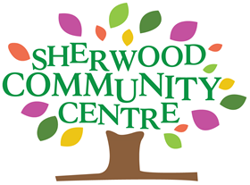
SHERWOOD COMMUNITY ASSOCIATION CIO

EQUALITY AND DIVERSITY STATEMENT

To protect the Community’s diversity, Sherwood Community Association CIO will not tolerate less favourable treatment of anyone on the grounds of their:

- Gender
- Age
- Race
- Colour
- Nationality
- Ethnic or national origin
- Disability
- Marital or civil partnership status
- Sexual orientation
- Gender reassignment
- Responsibility for dependents
- Trade union or political activities
- Religious or other beliefs
- or any other reason which cannot be shown to be justified
Sherwood Community Association CIO values Diversity!

Sherwood Community Association CIO believes and recognises that the diversity of the local community is a huge asset that should be valued and seen as one of the City’s great strengths.

The people who live, work, study in or visit Nottingham, have diverse backgrounds and circumstances. They are of all ages, races and ethnic backgrounds, disabled and non-disabled, are from faith and non-faith backgrounds
The Association supports the City Council’s commitment to providing equality of opportunity and tackling discrimination, harassment and intimidation, and disadvantage. We are also committed to achieving the highest standards in service delivery, decision-making and employment practice. This policy reinforces our responsibility under the Equality Act 2010 to ensure equality of opportunity for all sections of the community and our workforce, and in particular our general and specific duties:

General Duty

- Eliminate unlawful discrimination, harassment and victimisation and other conduct prohibited by the Act.
- Advance equality of opportunity between people who share a protected characteristic and those who do not.
- Foster good relations between people who share a protected characteristic and those who do not.

Unlawful discrimination will be dealt with in accordance with the Complaints Procedure.

